**MODULE – 4**

QU. 1 What are the main factors that can affect PPC bidding?

PPC bidding, also known as pay-per-click bidding, is a key factor in determining the success of your paid advertising campaigns. There are several factors that can affect PPC bidding, including:

* Keyword competition: The number of advertisers competing for the same keywords can have a significant impact on PPC bidding. The more competition there is for a particular keyword, the higher the cost per click (CPC) is likely to be.
* Ad relevance: The relevance of your ad to the keywords you are bidding on can also affect your PPC bidding. If your ad is highly relevant to the keywords you are bidding on, you may be able to secure a lower CPC than if your ad is less relevant.
* Quality score: Quality score is a metric used by search engines to determine the relevance and quality of your ads and landing pages. A higher quality score can result in lower CPCs, while a lower quality score can result in higher CPCs.
* Geographic location: The location of your target audience can also affect PPC bidding. Ads targeted to highly competitive geographic locations, such as major cities, may have higher CPCs than ads targeted to less competitive locations.
* Ad placement: The placement of your ad on the search engine results page (SERP) can also affect PPC bidding. Ads that appear higher on the SERP may have higher CPCs than ads that appear lower on the page.
* Time of day and day of week: The time of day and day of the week can also affect PPC bidding. Advertisers may find that certain times of day or days of the week have higher or lower CPCs based on the behavior of their target audience.
* Bidding strategy: Finally, the bidding strategy you choose can also affect PPC bidding. Different bidding strategies, such as manual bidding or automated bidding, can impact the amount you pay per click and the overall success of your campaigns.

QU.2 How does a search engine calculate actual CPC?

A search engine calculates the actual CPC (cost per click) through an auction-based system known as pay-per-click (PPC) advertising. When an advertiser sets up a PPC campaign, they select certain keywords they want their ads to appear for when someone searches for those keywords. When a user enters a search query that matches the advertiser's selected keywords, the search engine will display the advertiser's ad alongside the organic search results.

To determine the actual CPC, the search engine runs an auction for each search query that triggers an ad. In this auction, the advertiser's bid for the keyword they've selected is compared against the bids of other advertisers who have also selected the same keyword. The search engine then ranks the ads based on a combination of the bid and the ad's relevance and quality.

The actual CPC that an advertiser pays is determined by the following formula:

Actual CPC = (Ad Rank of the Advertiser Below / Your Quality Score) + $0.01

In other words, the actual CPC is equal to the Ad Rank of the advertiser below you, divided by your Quality Score, plus one cent. The Quality Score is a measure of how relevant and useful the ad and the landing page are to the user's search query. The higher your Quality Score, the lower your actual CPC will be. The Ad Rank is a value used by the search engine to determine the order in which ads are displayed, based on the bid and quality score.

So, the actual CPC that an advertiser pays will depend on their bid, their Quality Score, and the bids and Quality Scores of other advertisers competing for the same keyword.

QU.3 What is a quality score and why it is important for Ads?

In online advertising, a quality score is a rating given to an ad or a keyword that helps determine its position on a search engine results page (SERP) or placement on a website. Quality score is typically calculated based on a combination of factors, including the relevance of the ad to the search query or website content, the click-through rate (CTR) of the ad, and the landing page experience for users.

Quality score is important for ads because it directly affects their visibility and cost. Ads with higher quality scores are more likely to be shown in top positions on SERPs or premium ad placements on websites, while ads with lower quality scores may not be shown at all. Additionally, ads with higher quality scores often have lower costs per click (CPCs) and can achieve better ad placement at a lower cost compared to ads with lower quality scores.

Overall, improving the quality score of ads is an important factor in optimizing online advertising campaigns and can lead to better performance and return on investment (ROI).

QU.4 Create an ad for http://esellerhub.com/ to get the maximum Clicks

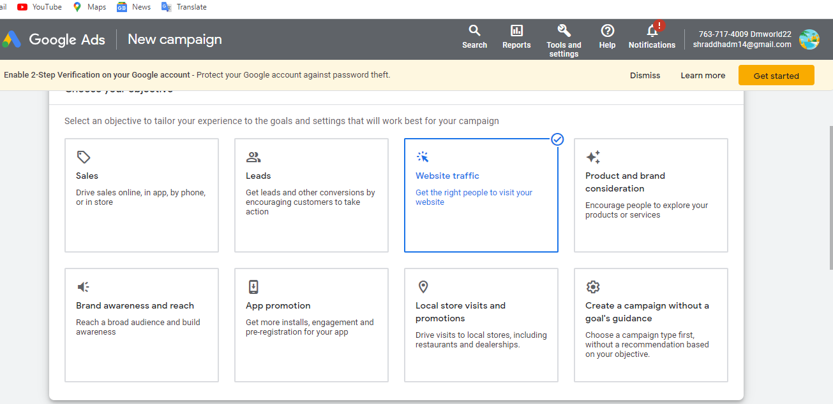

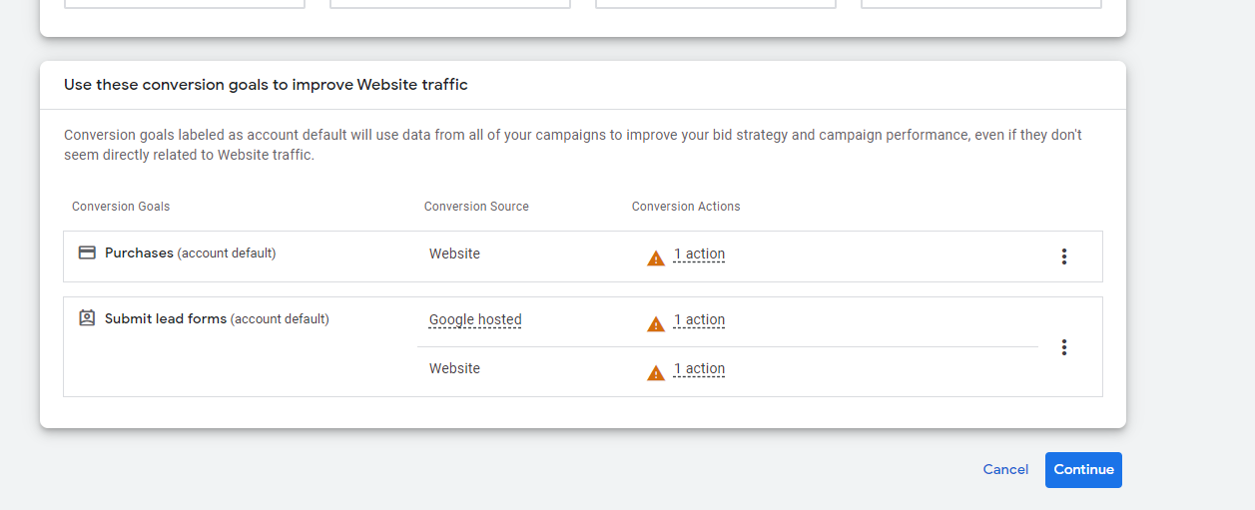

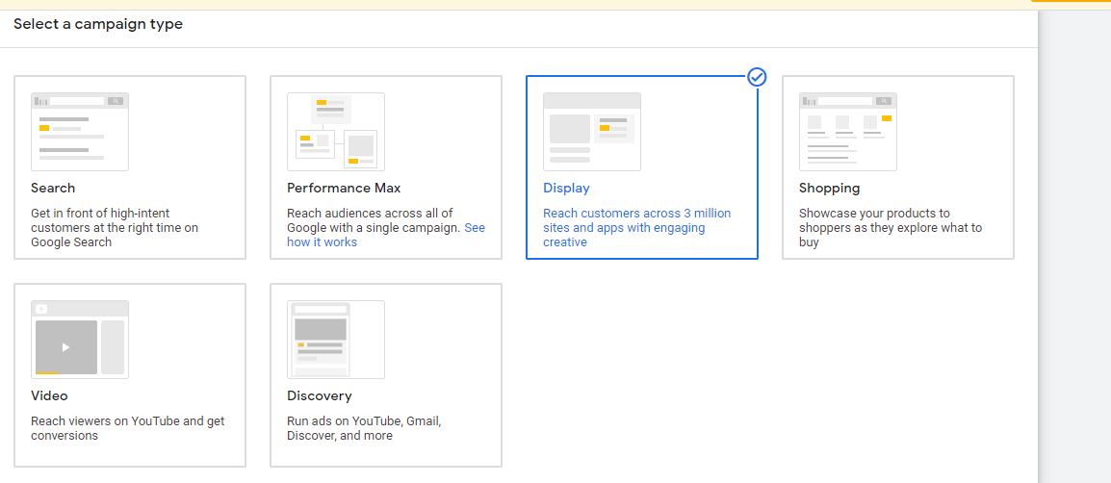

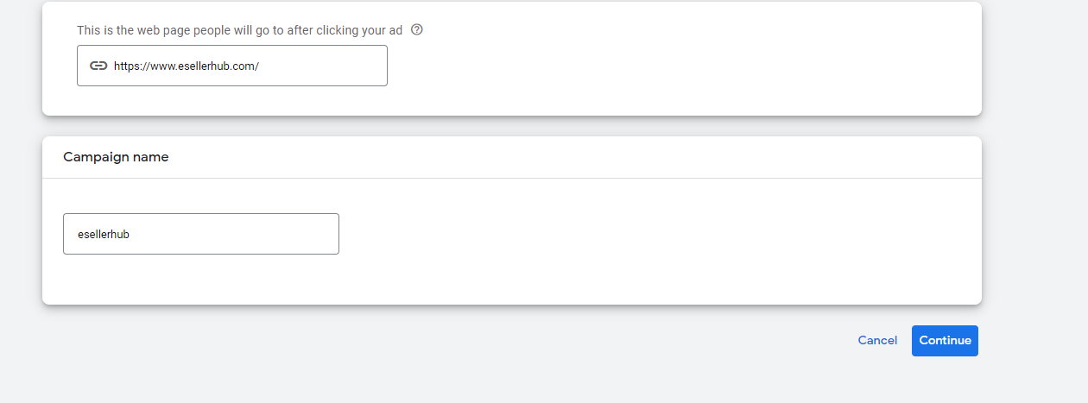

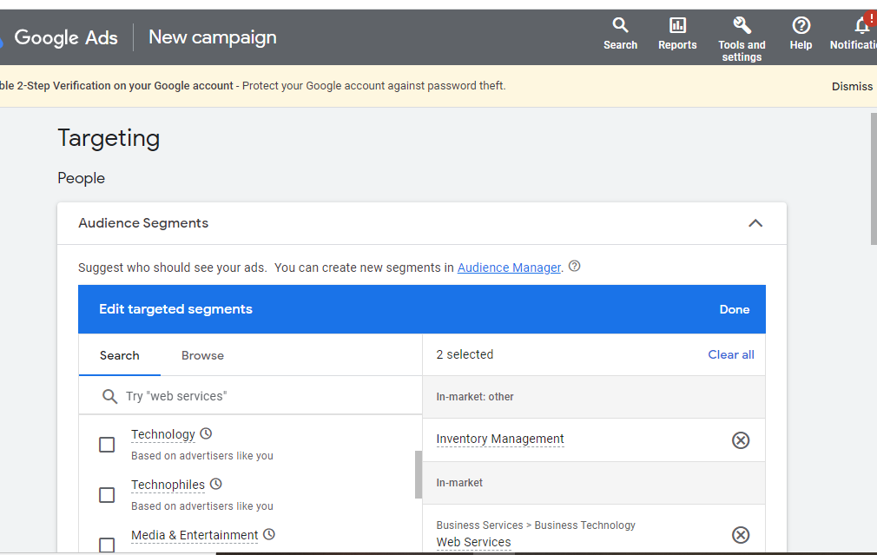

Top of Form

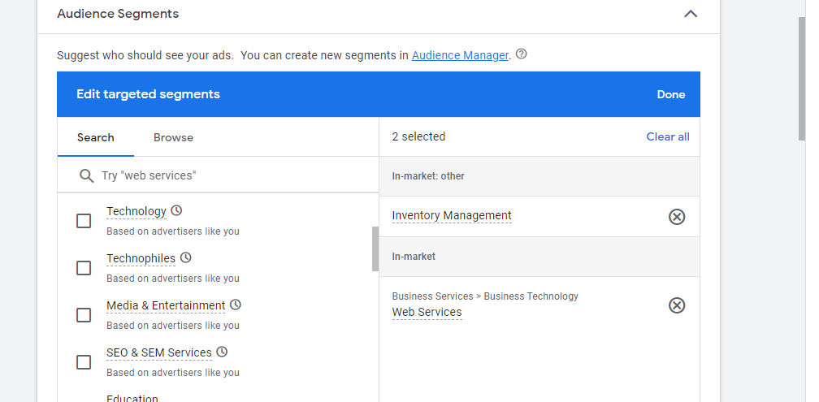

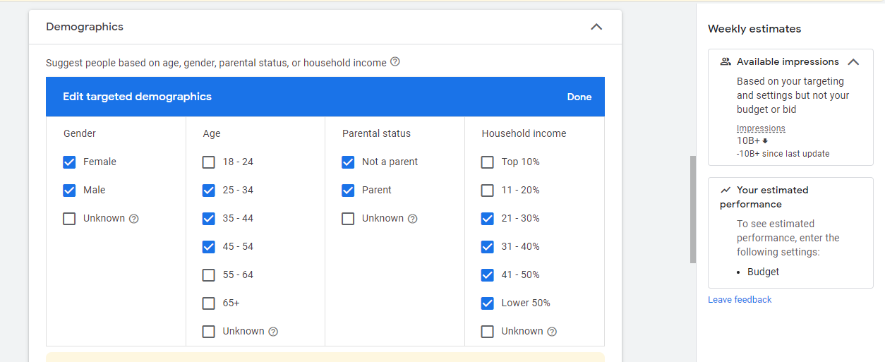

QU. 5 Create an ad for your website/ blog in Google Ads that display on the display network with the properly targeted audience

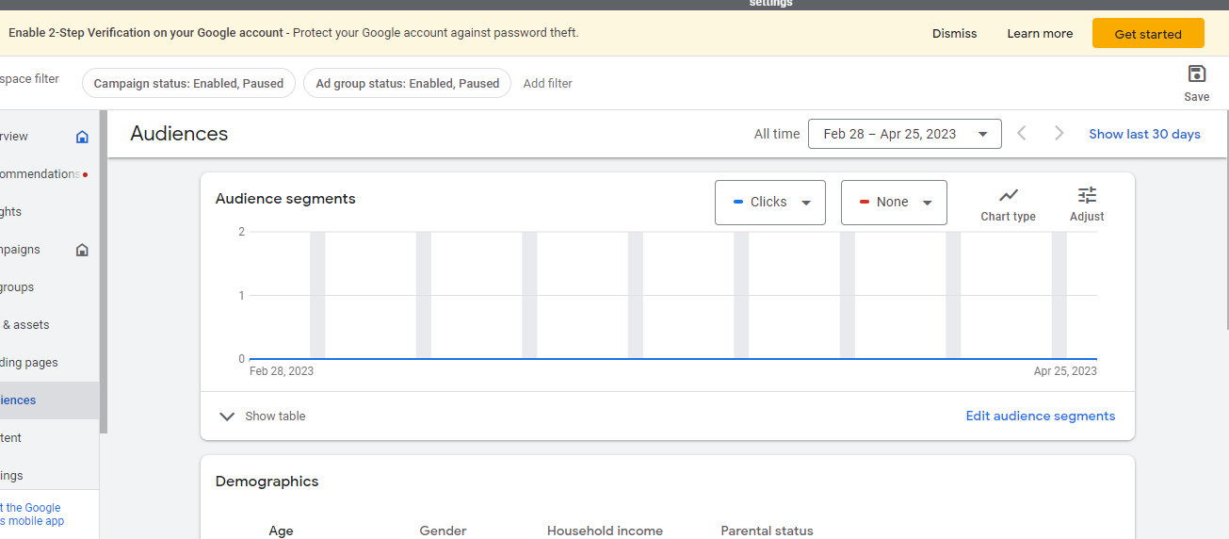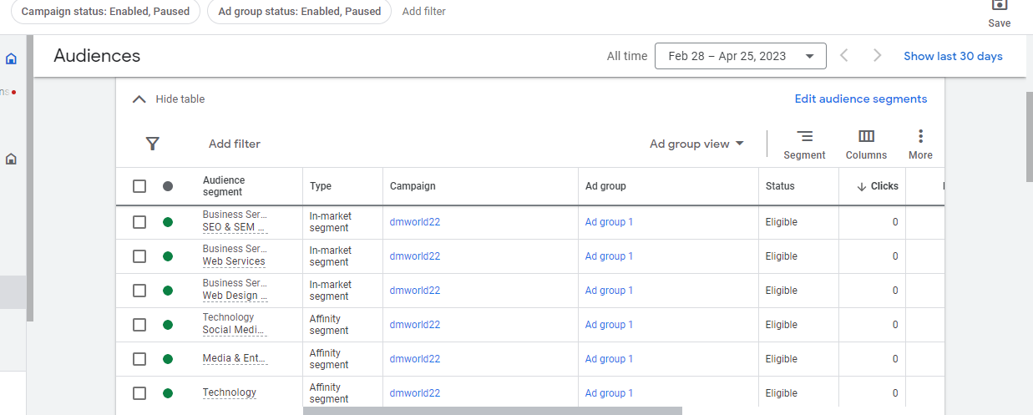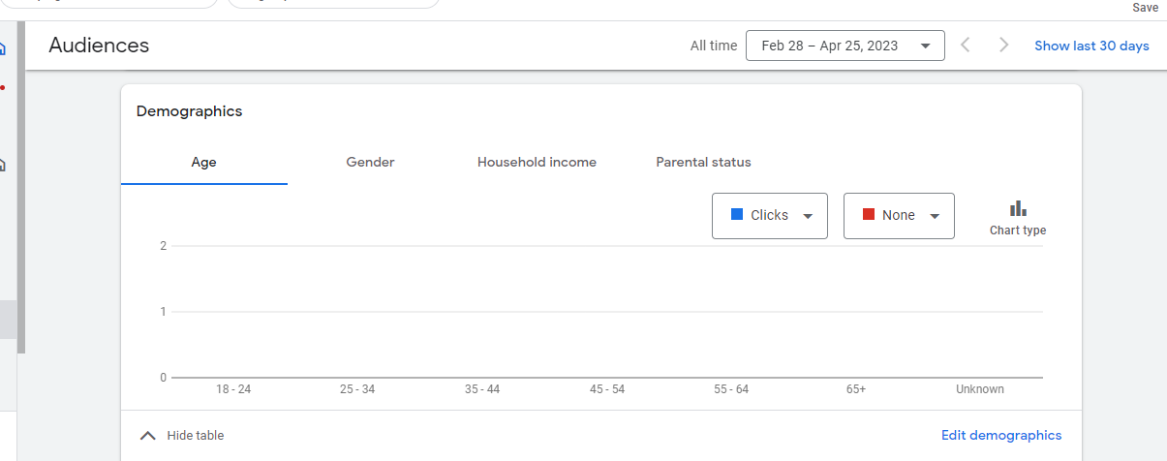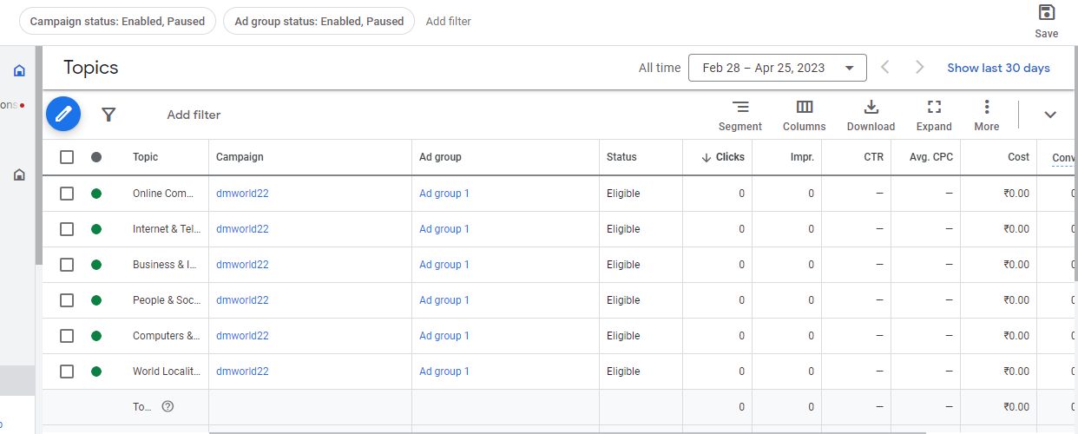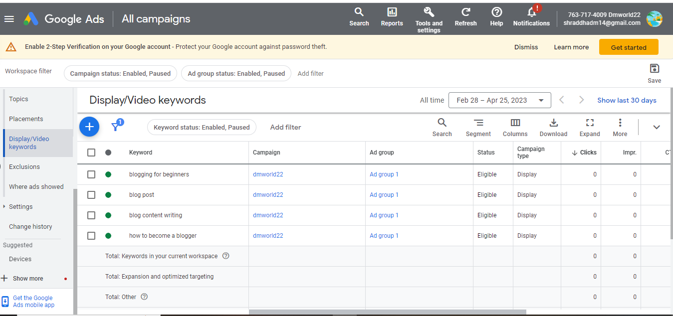

QU. 6 Create an ad for <http://www.designer2developer.com>

* Create an ad for the display network.
* Choose a proper Target audience.
* Expected conversion: need maximum user engagement within the budget.
* Budget: 5000

